

**Smart Fitness Centre**

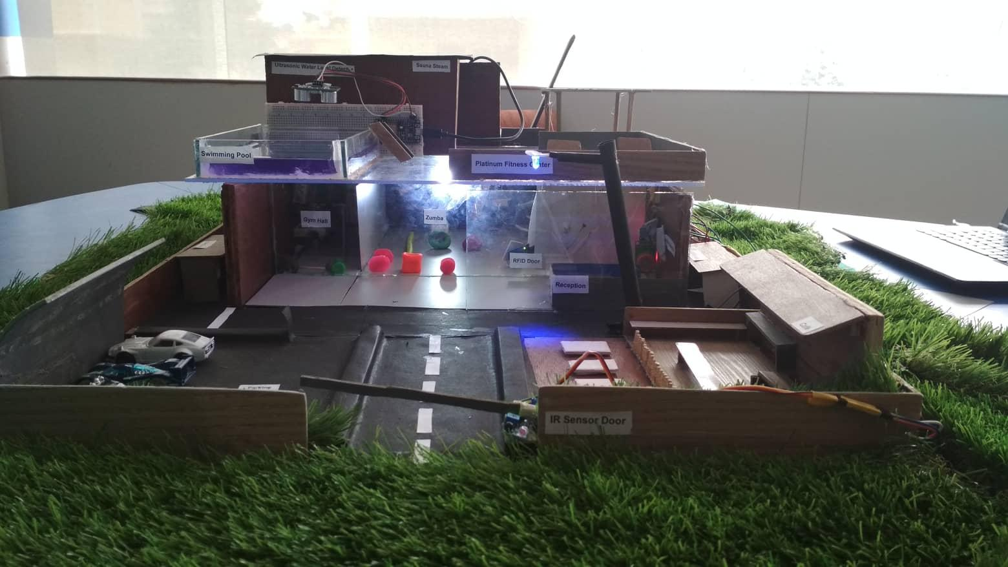

**Module: STW307CR-Interactive Pervasive Computing**

**Softwarica college of IT and E-Commerce**

**Mahakavi Marg, Kathmandu 44600, Nepal**

**Submitted by: Submitted to:**

Deepu Khadka (9635795) Manoj Shrestha

Sanjaya Paudel (9637711)

Kushal Neupane (9635913)

Sanjay Shrestha (160225)

Mamta Kumari Chand (9635968)

**Batch:** 19B

**Table of Contents**

1. Introduction 3

Aims 4

Objectives 4

2. Research and background 5

3. Proposed System 6

4. Justification 7

5. System design and implementation 9

5.1. Devices and Sensors used in the prototype 11

5.2. The Build or Circuit Layout 14

5.3. Sketch 18

5.4. How it works 21

6. Risk Assessment 22

6.1. Risk analysis and plan 22

6.2. Gantt Chart 23

6.3. Project Initialization 24

6.4. Project Cost Plan 24

6.5 Project Cost statistics 24

7. Other Application 25

10. Future works 28

11. Conclusion 29

12. References 30

**Table Of Figures**

Figure 1. Problem Statement 8

Figure 2. Solution 8

Figure 3.HC-SR04 12

Figure 4.RFID 12

Figure 5: Servo Motor 13

Figure 6:IR Sensor 14

Figure 7:MQ3 Sensor 14

Figure 8: DHT sensor 15

Figure 9. RFID DOOR 16

Figure10.Temperature control circuit layout diagram 17

Figure 11.Automatic light using IR sensor 17

Figure 12.IR Sensor and Servo Motor 18

Figure 13.RFID Connection With Servo Motor 19

Figure 14.Risk Plan 24

Figure 15. Gantt chart 26

Figure 16.Office 28

Figure 17.Hospital 28

# 1. Introduction

Gym centre is a place for maintaining fitness of the people where gymnastic services, facilities and equipment are available. We don't have a meaning of having a big house, fancy car and IT degree without a health. At first, we should be healthy and being healthy gives us energy to do anything.

Our project (Platinum Fitness Centre) is a smart centre with full of services and facilities which provides well maintained facilities to improve your health. Some smart technology are used in this project, some of them are: smart gate which detects people or vehicles and opens automatically for few seconds, RFID door system where authorized people can access only, alcohol detector detects drunk people and don’t give access to them, smart light which works automatically (‘ON’  ‘OFF’) in the case of people available in the centre or not, smart fan which detects the current temperature and work automatically, smart pool for managing water level.

# Aims

The main of this project is to create and idea so that every gym can implement suitable technology for providing better facilities to the gym members.

# Objectives

* To implement efficient and reliable sensors in the gym
* To improve security
* To allow members with faster and easier facility
* To implement real time data communication between gym administrator and members via any smart devices
* To track every asset in the gym
* Monitoring and Controlling system for fitness design and implementation with an IoT based.
* Benefits Evaluating proposed with compared conventional solution.
* Reduce the cost with improving the productivity purpose in future.

# 2. Research and background

Proper research has been done by us before we are starting this project. This system project is proposed on smart devices that automated the sensors with environmental phenomena. It provides the new innovations facilities and services to the users and owners by sensing the objects and devices. It makes devices smart and make the users life smarter and easier. Existing System and Problem an Existing system refers to the system that is being manually followed till now. The current system is more costly and time consuming due to the involvement of more labour and electricity consumers. There need to be study research to find out the existing system problem which will make us to finding out more requirement for the new system. It always gives alternative finding result for better solution. To handle the system was very complicated task. But computerization made easy to work. The following are the measures reasons why the current system should be computerized:

* To increase efficiency with reduced cost.
* To reduce the burden of labour and staff charges.
* To save time management for recording

# 3. Proposed System

The Smart Fitness Centre is user-friendly application which is automated system makes all functionality easier. Implementation of design is easy in this system project. The system resources are very and work in almost all configurations which has following objectives

* Maintenance Cost
* User Friendly
* Automation
* Accuracy

# 4. Justification

Figure 1. Problem Statement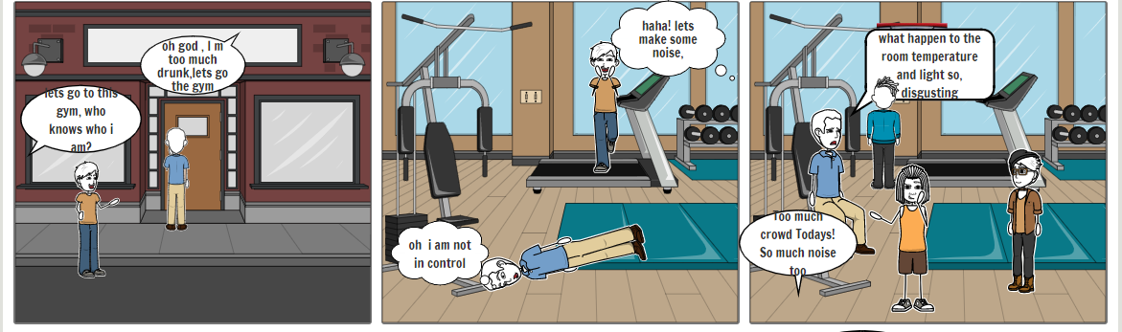

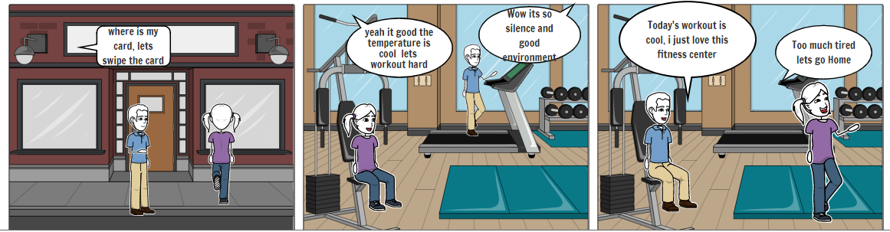

Figure 2. Solution

Fitness Centre is lacking smart sensors tools and technology. Air control, light control, security measures are lacking behind. Even though the fitness centre can’t provide the good environment to pump the training for the trainers. Temperature changes, excessive unauthorized persons, lightning function are the measures problems that makes the fitness centre behind. How it Look when all this is smart and well automated with IoT and Why it should have to be? Connected IoT devices in fitness centre performs high level of quality progress on working based. Labour charge can be reduced in security measures by connected biometric sensors on doors and automated parking system. The consumption of electricity also can be reduced by automatic light sensors where the temperatures changes with environmental phenomena corporates with smart devices. Moving back to time, now corporate gyms and locals are moving to smart tools. Fitness clubs are changes drastically and starting to modify with offering accommodate facilities. With the innovations and technology, the fitness centre of the future will be push to an elite new level.

# 5. System design and implementation

In platinum fitness centre, some smart functions and technologies are used for providing good facilities and security system. This fitness centre is a compound where parking system, cafeteria and toilets are available in the outside of the building part. Gym, jumba, swimming pool, sauna steam and other technology are available inside the building. In the main gate, IR sensor is used which detects people and vehicles in specific distance. The gate opens automatically with the help of servo motor after detecting people or vehicle. So that, people can go to the building, cafeteria and for parking without any effort. In the main door of the building, some security systems are used. RFID door system is a security system where authorized people can access only. People should be registered first and take an RFID card from the reception which is near to the main door. Two LEDs (Red and Green) and buzzer are also attached in the main door to manage security system. If unauthorized people try to open the door using any items, the red bulb glows and buzzer give a long sound as a warning alarm. And green LED glows and buzzer gives short sound in the access of authorized people. The RFID card contains a tag which is registered in the database and it is put near to the RFID reader to open the door. Another security system is alcohol detector which is attached on the main door of the building near the RFID reader. MQ3 sensor is used in alcohol detector system which detects the threshold of the air or gas and gives response in a range of threshold. This sensor is used on the side of the door of the building to detect the range of alcoholic threshold. In the main door of the building, breath of the people is tested either he/she is drunk or not. If the drunk people breath to the alcohol detector device, red bulb glows, buzzer gives a sound like alarm and door remain closed. People can access the door only after completing the two tests of the security system. There is a big hall which contains two parts for GYM and JUMBA respectively. Smart light and smart fan are available in that hall. IR sensor is used in smart light system which detects the availability of the people in the hall. The light glows ON automatically if a person is present in the hall. And it remains OFF if no-one is there in the hall. People are tired after completing their task and go for rest and food quickly. At that time, many people forget to switch OFF the light, so, smart light is important. In smart fan, LM35 sensor is used to detect the current temperature of the room and rotates automatically if the temperature rises. In the top floor of the building, swimming pool and sauna steam are available. Ultrasonic sensor is used in the swimming pool to detect the level of water into it. It sends the message to PC whether water need to fill in or take out. And the display board is attached on the wall of the sauna steam building for displaying the temperature. These are the smart technologies used in this project (Platinum Fitness Centre).

## 5.1. Devices and Sensors used in the prototype

**Sensors and Implementation in devices**

* **Ultrasonic (HC-SR04)**
* Ultrasonic sensor detects the distance of object from its position. In this system, it is used for detecting the water level in swimming pool. (What is an Ultrasonic Sensor?, 2019)

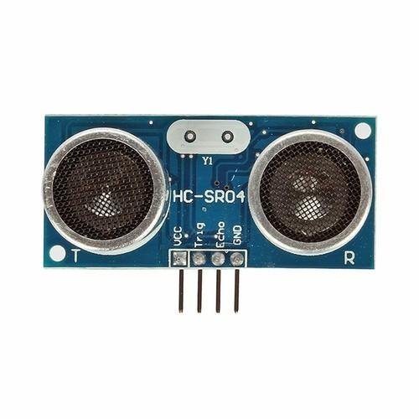

Figure 3.HC-SR04

* **RFID Reader and Tag**
* This is used for authentication and authorization. It has been used to identify gym members about their membership detail.

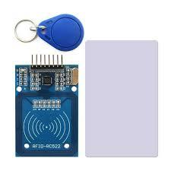

Figure 4.RFID

* **Servo Motor (Automatic door)**
* To allow only authorized members to enter into the Gym, servo motor is used to open or close door as per the data provided by RFID reader.

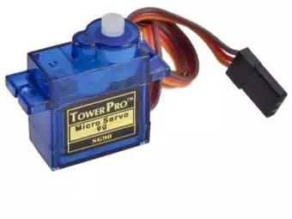

Figure 5: Servo Motor

* **IR sensor**
* This sensor works almost like ultrasonic but it detects to smaller distance. It was to open the main door and for automatic light.

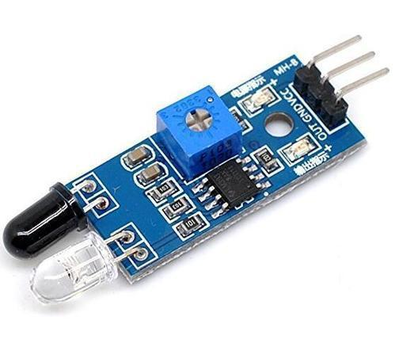

Figure 6:IR Sensor

* **Alcohol Detector (MQ3 Sensor)**
* Alcohol detection or breathalyzer analyzes breath information and generates a value based on the analysis. A threshold was set for the value and based on the threshold, gym members are qualified or disqualified to enter the gym.

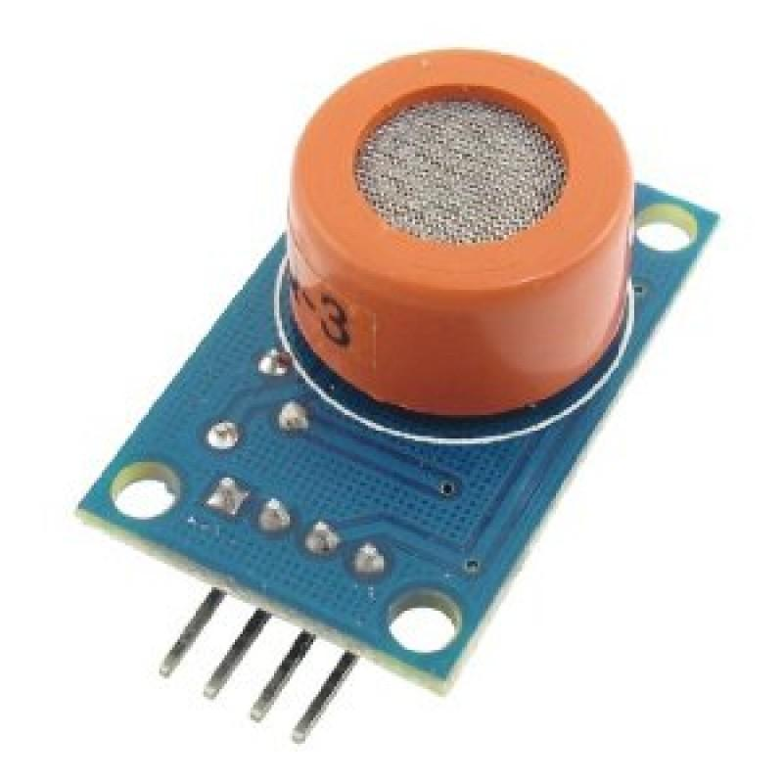

Figure 7:MQ3 Sensor

* **Temperature and Humidity Sensor (DHT sensor)**
* DHT sensor generates information about temperature and humidity of the environment it’s in. This was used for automatic fan; the fan was automatically turned on or off based on the current temperature and humidity reading. Also, this was used to show current DHT information in front of the Sauna.

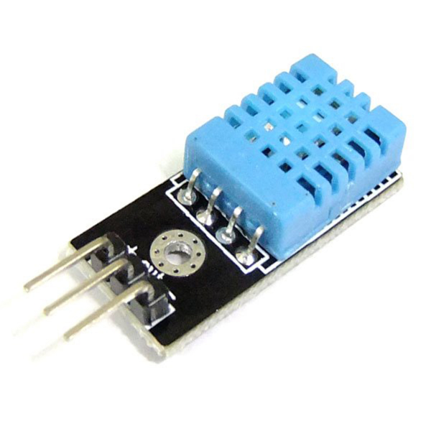

Figure 8: DHT sensor

## 5.2. The Build or Circuit Layout

**RFID circuit Layout diagram**

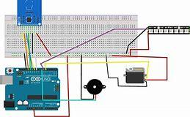

Figure 9. RFID DOOR

Temperature control fan circuit Layout diagram

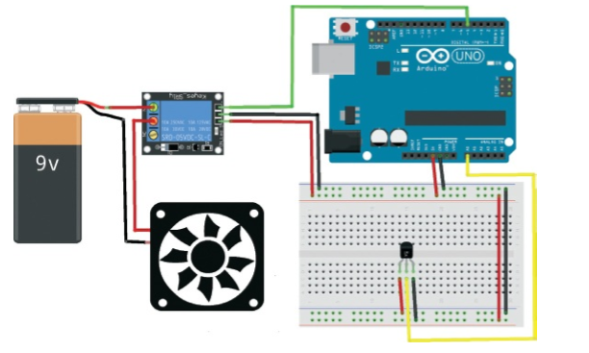

Figure 10.Temperature control circuit layout diagram

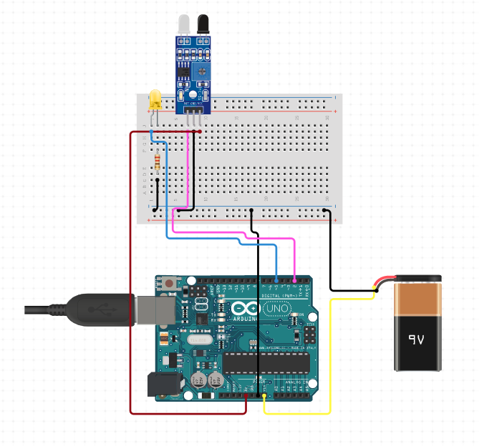

Figure 11.Automatic light using IR sensor

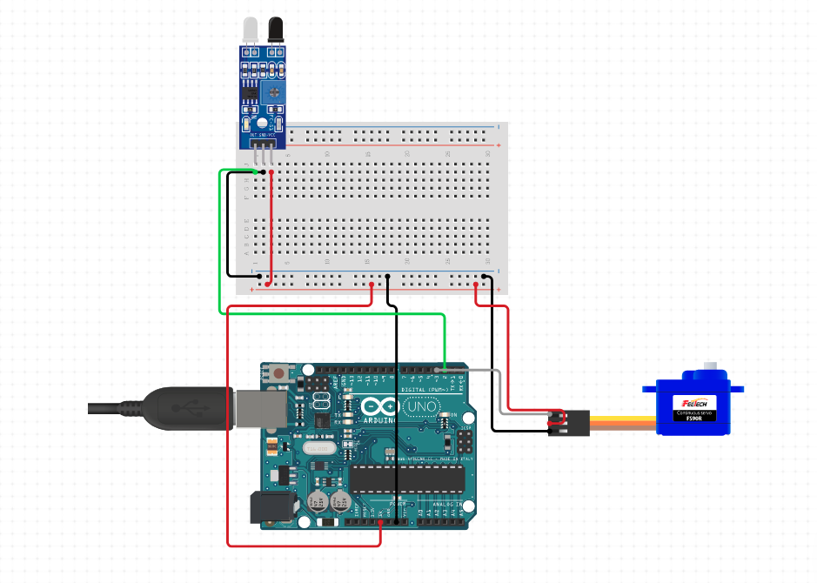

Figure 12.IR Sensor and Servo Motor

* 1. 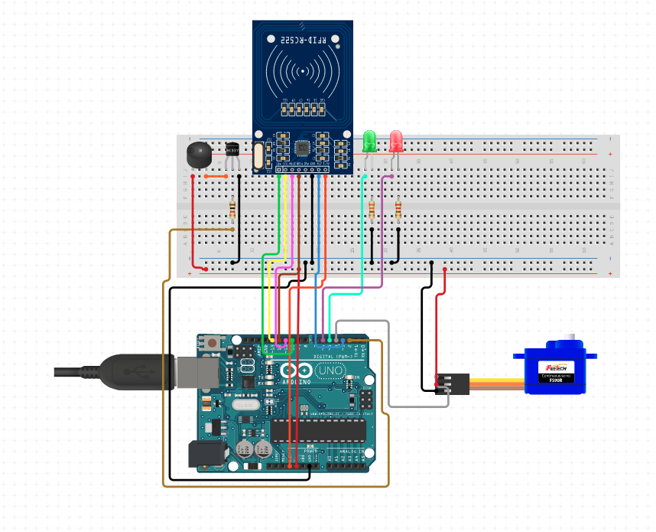

Figure 13.RFID Connection With Servo Motor

## 5.3. Sketch

**RFID sketch**

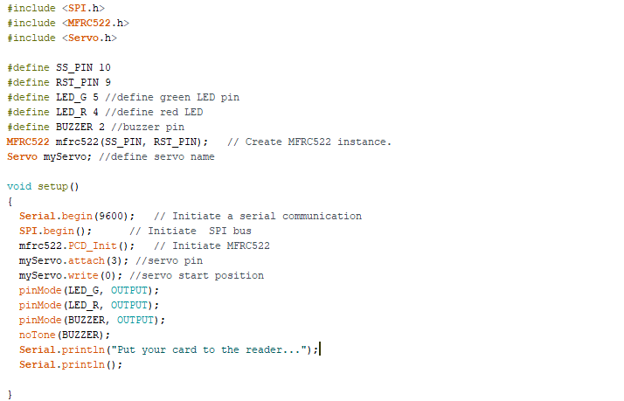

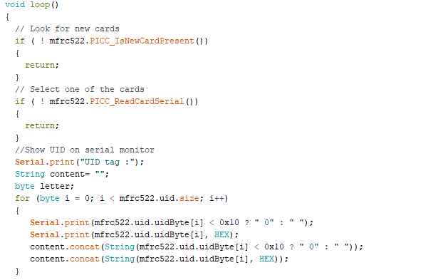

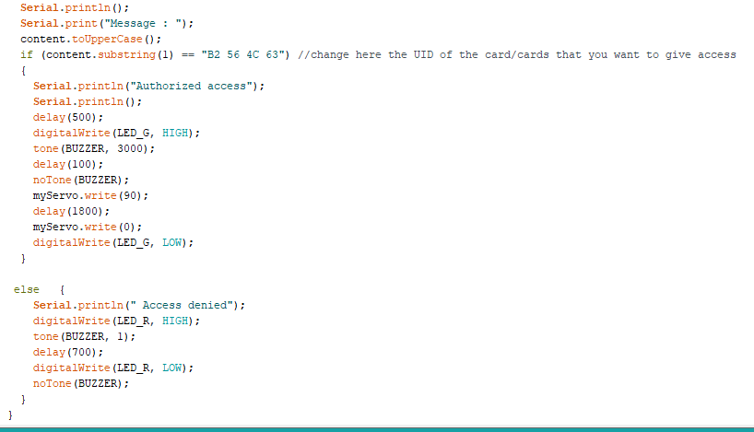

**Smart Temperature Code**

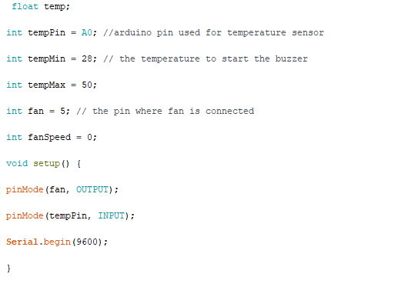

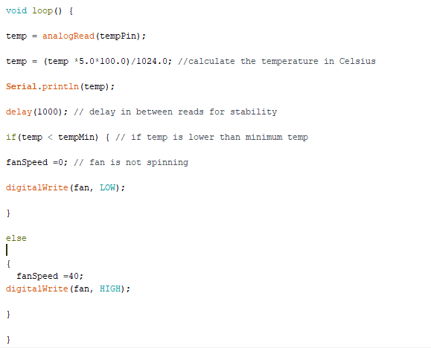

# 5.4. How it works

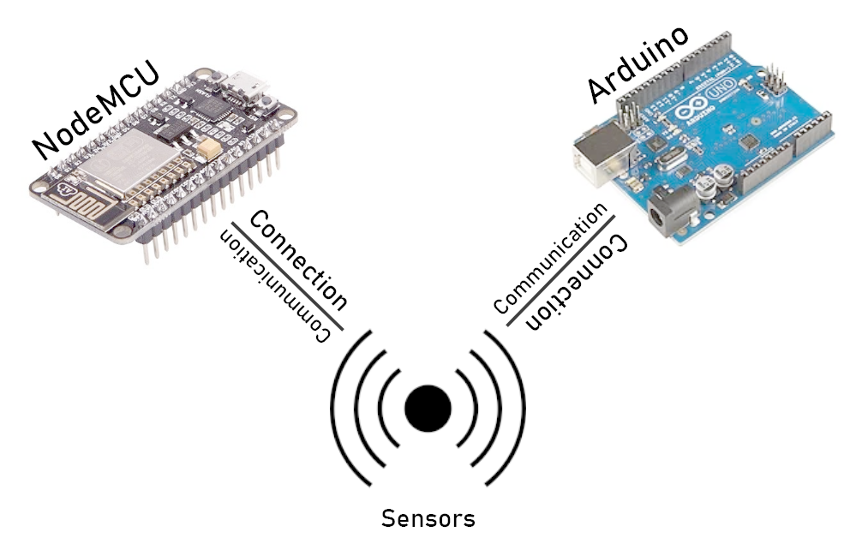

Fig. How it works

As shown on the above picture, we have controllers like Arduino and nodemcu which allows us to program our system. Controllers are connected to different sensors. Sensors read sensor data and values which are used and programmed in controllers as our need. Nodemcu has an extra advantage of Wi-Fi module which means that the data can be sent to the internet through Wi-Fi. We have connected sensors to nodemcu whose values are required to be sent to dashboard for real time view. Otherwise Arduino was used for live product view.

# 6. Risk Assessment

## 6.1. Risk analysis and plan

Risk is something which exposes anything to danger that might later turn into an issue. It must be analysed and planned proactively before it turns into issue.

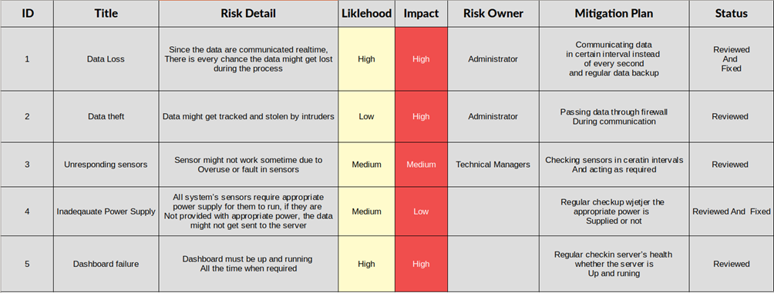

Figure 14.Risk Plan

## 6.2. Gantt Chart

Gantt chart is a task management tool which was used for assigning initial and deadline for different tasks along with respective member information.

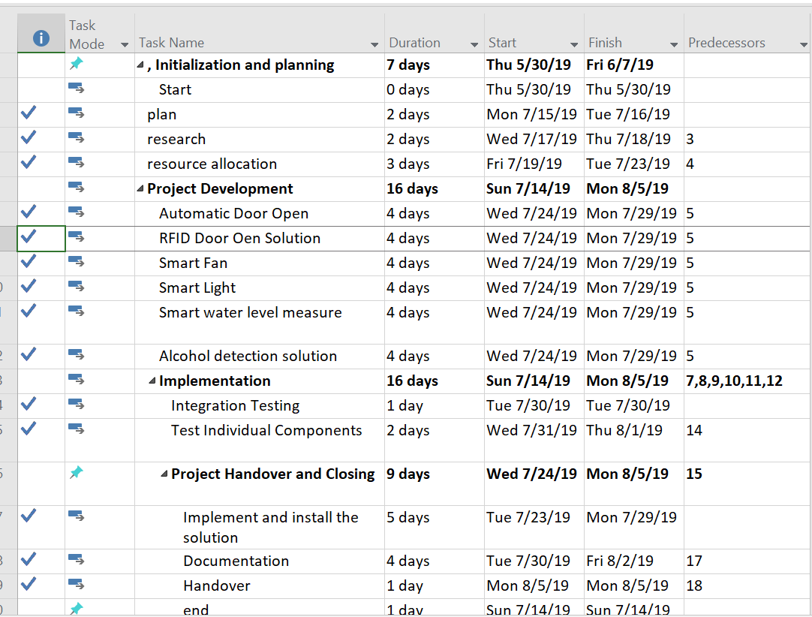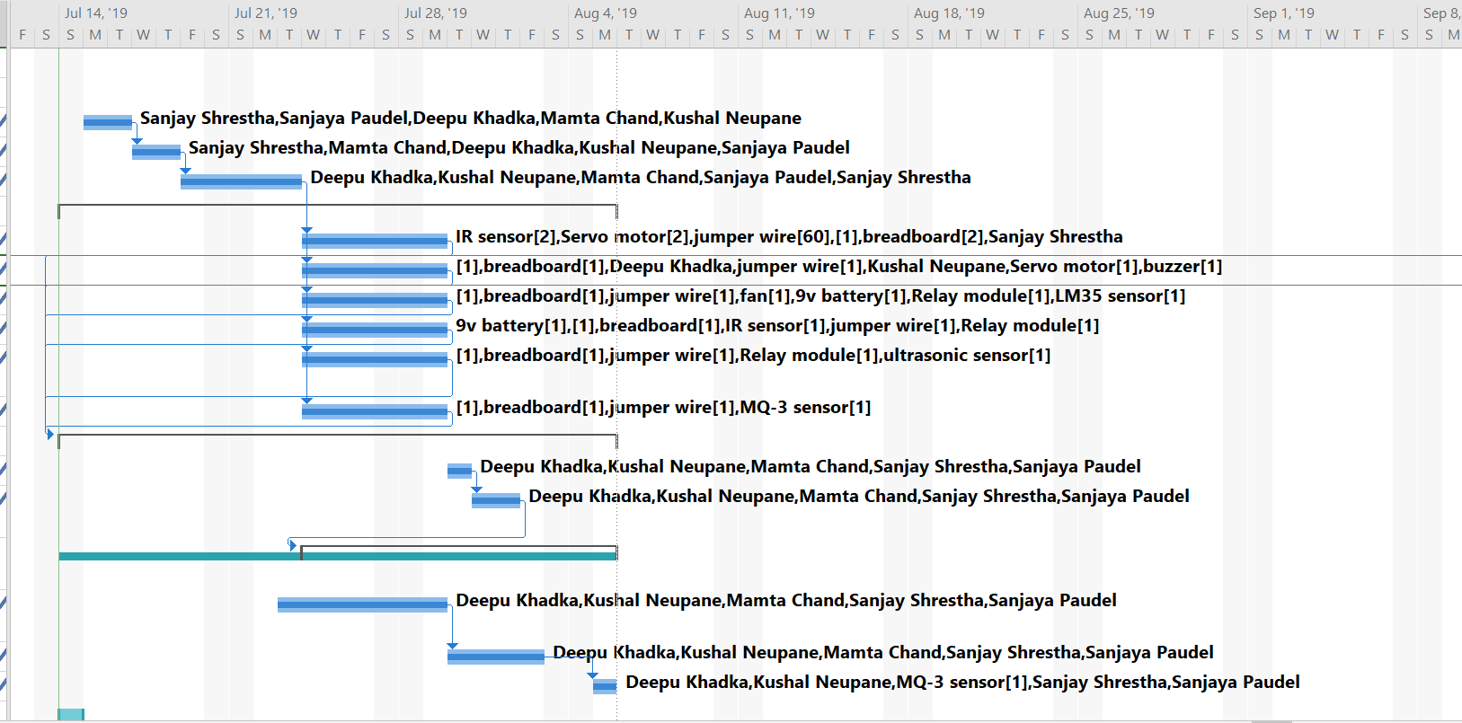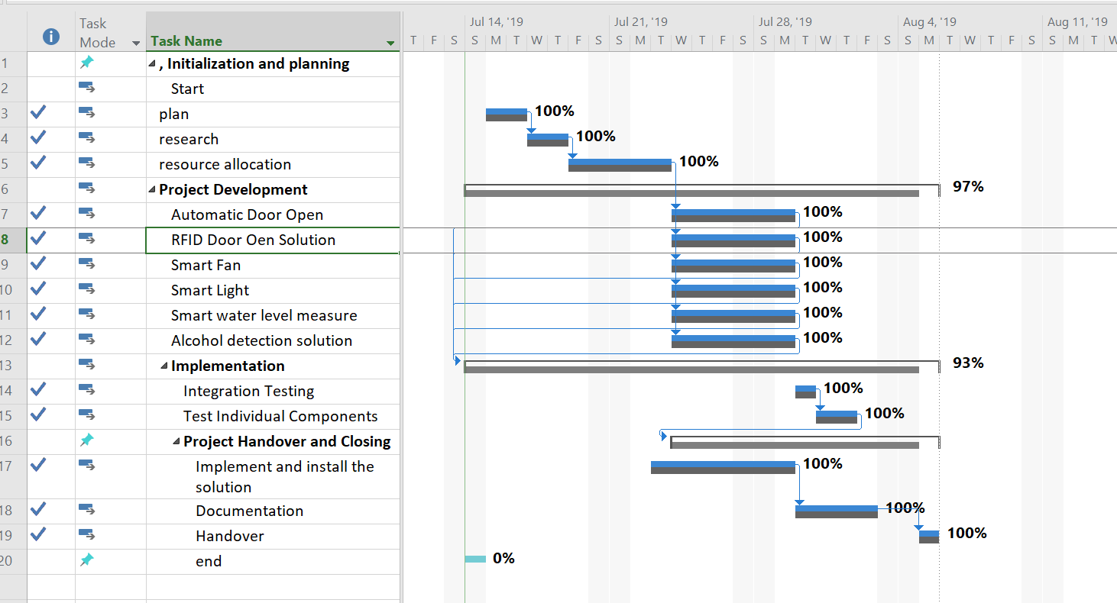

Figure 15. Gantt chart

## 6.3. Project Initialization

First, the whole project was broken down into smaller tasks then individual tasks were assigned with certain deadline and initial time. All smaller tasks were done via group members to meet the corresponding deadline.

# 7. Other Application

This system can be implemented on other areas as well: Hospitals, office, hotels

Office

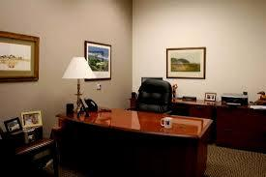

Figure 16.Office

Hospital

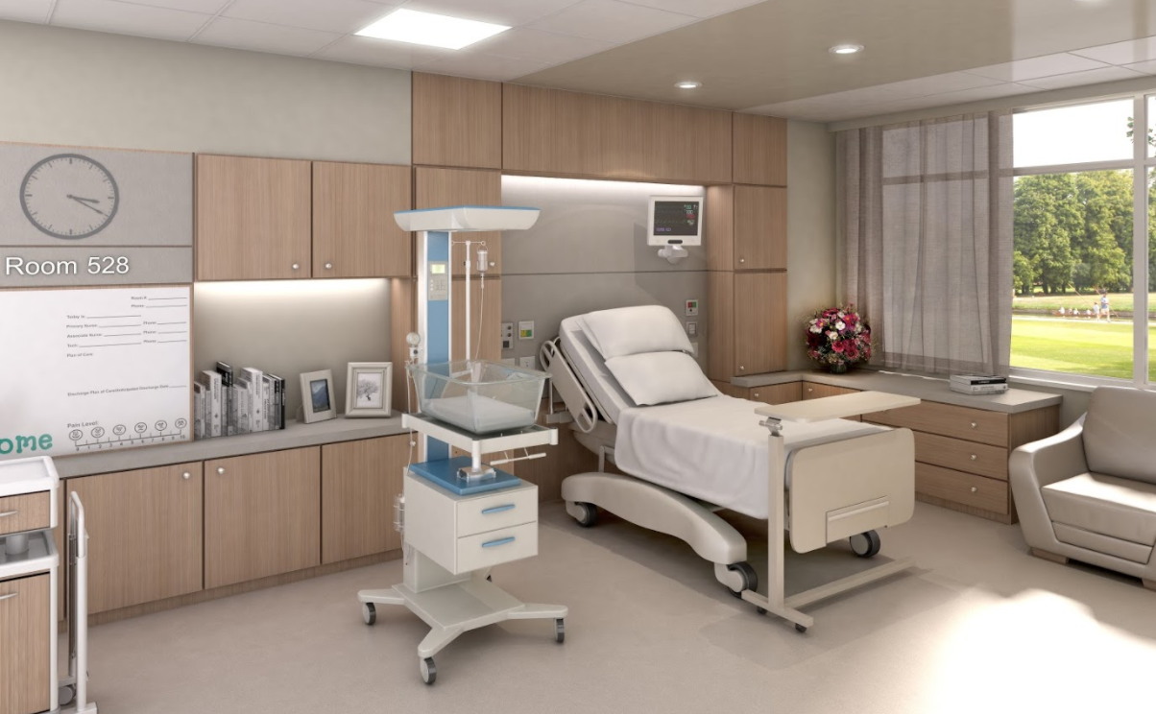

Figure 17.Hospital8. Testing

Testing is an important part after completion project work. Testing should be done to know that either the prototype actually works or not according to our expectation. We faced some difficulties and problems in the pin connection between the devices. Our main challenge of our project was to recover the pin connection problems which was already managed in a place. In average condition of the WIFI connectivity, we were not able to load the value of water level in the dashboard using Ultrasonic sensor. We were in a dilemma of our main layout or design of the project and to manage all device connections into the design. After some research of the connection of Arduino IDE and other devices and help from our teachers and friends, we were able to complete the main layout and manage the devices in the layout properly. After managing all devices in the layout, problems were occurred in the pin connection and devices when testing. After re-connecting and changing the pin connection between the devices, the problems were solved and other testing was passed.

**9. Troubleshooting**

**Code**

There were times when sometimes sketch code was not uploaded to the Arduino and node MCU board, sometimes there was a logical error in the code, sometimes Arduino was not installed properly. All these problems were fixed by reviewing and testing multiple times.

1. **Components**
   * 1. Every component were not working properly. All components were rechecked and replaced with properly working one.

# 10. Future works

**Robotics**

In Smart fitness Centre, the robotics can be implemented as a coach for trainers where one robot can train 6 people in one time connected with digital device sensors.

**Water Filling**

Automatic water filling on swimming pool can be implemented when the water level of the pool is decreased.

**Wearable Sensors**

The wearables sensors devices can also be implemented to track the trainers in smart centre about their performance and capabilities.

**Notification Alert**

The mobile application alert notification about the nutrition diet and workout schedule of the members can be implemented by tracking the assets in real time location system

# 11. Conclusion

Thus, the system was developed as planned. System was divided into smaller tasks which was assigned to different team members along with task deadline. Finally, all the tasks were completed on time and a brief documentation was produced.

# 12. References

What is an Ultrasonic Sensor? (2019).

Retrieved from keyence:[Accessed July 14, 2019] https://www.keyence.com/ss/products/sensor/sensorbasics/ultrasonic/info/index.jsp

**Personal Challenges**

(Deepu Khadka)

Doing a project in a team was a big challenges. Everyone’s effort was important on each tasks, without a team involvement it won't be possible to get success.

Chunks of works is divided to the team members. Designing concept and the system workflow was done by the whole team. Designing architecture was the main challenging. so i had made research on the architecture design for the project

So I consult to my team members about the design without them the system architecture design was be the worst part.

In setup time, i had faced the problem on the water level detection using ultrasonic sensors. The data was having to shown on live on dashboard by fetching API.

Later on, whole members of my team were there try to fixed it out the problem.

The speaking part for the exhibition was another challenge for me. Describing the project for an hour to the visitors was so challenging. so, the presentation

part has been divided to the members. So, it makes tasks easy to each member that saves the time and maintain good collaboration with each other’s. Whole members of my team had

equally contributed their efforts and skills for the successful development of the project.